Name: Bhatt Saumilkumar Pramodbhai

Id: 000838181

1. What are State diagrams and what are they used for specifically? Elaborate and provide an example.[2]

* State diagrams depict the system's overall behavior. State diagrams are primarily used to represent states and transitions. States are represented by rectangles with rounded sides and the name of the state written on them. Transitions are indicated by arrows pointing from one state to the next, indicating how the states change.

1. How are State diagrams different from Class diagrams? Are they complementary to Class diagrams or serve a totally different purpose?[1]

* A class diagram shows classes in their relation and their properties and methods.
* A state diagram visualizes a class's states and how they can change over time.
* In both cases you are talking about diagrams which are only a window into the model. The class relations define how the single classes relate to each other. A state machine can be defined for each class to show its states. In embedded systems you use state machines almost all the time but there are also state machines for business applications (you can do this if that).

1. How are the different types of relationships represented in a state diagram?[2]

* In state diagram we do not define relation ships but we define state and its transitions.

1. Draw a State diagram to illustrate the different states of PC usage in a computer lab at Mohawk College, from the time you turn it on at the beginning of a lab session until you shut it off. Four distinct states will suffice for this question (two states per student in a team with your names attached to the two diagrams). [4]

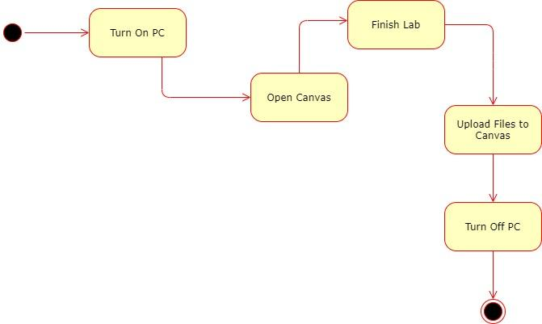

**References**

1. <https://www.lucidchart.com/pages/uml-state-machine-diagram>
2. <https://stackoverflow.com/questions/28769689/class-diagram-vs-state-diagram-uml?rq=1>
3. https://www.visual-paradigm.com/servlet/editor-content/guide/uml-unified-modeling-language/about-state-diagrams/sites/7/2019/12/state-machine-diagram-explained.png